Miniature Astronomy

By Quang Huynh

Some scientists, named WASP (Wide Angle Search for Planet) have discovered a star the size of Saturn, and scientists call that miniature star “EBLM-J0555-57Ab.” The peewee star has 300 times more mass of the planet Saturn, but is still tiny to the mass of the sun. EBLM-J0555-57Ab has only 8% of the Sun’s mass. Also, scientists have discovered that the small star also orbits around another star, bigger than the size of EBLM-J0555-57Ab. The WASP Scientists has discovered EBLM-J0555-57Ab with a technique used to find exo-planets. 2 observations that I found is that, EBLM-J0555-57Ab is smaller than the star than it is orbiting, another observation that I see is that, the tiny star has 7 planets almost the same size as Earth. Now, the inferences. Firstly, an inference on the star, EBLM-J0555-57Ab, is that there could be life on one of its 7 Earth sized planets. Secondly, another inference that I have is that, it is not the smallest star in the observable universe, I think there are even smaller stars that we have yet to discover. That is it for the small star.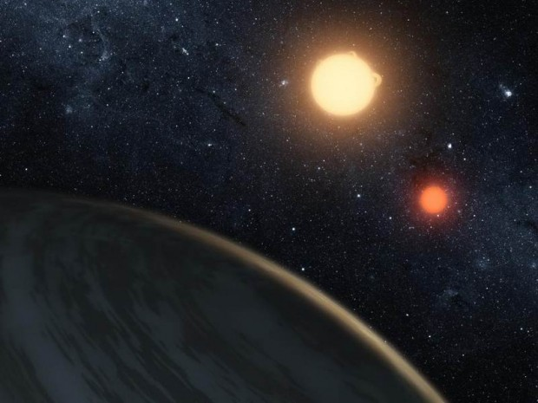

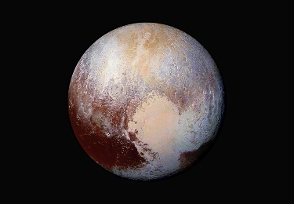Another miniature object in outer space is Pluto, a planet right in our Solar System! Well “dwarf planet,” as scientists had decided that Pluto was too small to be a planet, so, scientists had removed Pluto as a planet and into a dwarf planet. Now, let’s get into the history of this dwarf planet named Pluto. Firstly, it was discovered on February 18th, 1930 by an astronomer named Clyde Tombaugh, making Pluto the ninth planet. But in 2006, scientists had changed the planet now into a dwarf planet.

An observation about Pluto is that, it has six moons, which are named Charon, Hydra, Nix, Kerberos, and Styx. The biggest moon is Charon. Another observation about Pluto is very interesting. It is that Pluto is only half the size of the United States wide, or about 740 miles, which would be the radius of Pluto. An inference about Pluto is, most astronomers do not think Pluto is a planet. Another inference is that, Pluto might be considered a planet again, but the chances of that happening is slim.